

Best Practices

The Concierge Assistant

Package Processing

The Concierge Assistant is vast in its scope of abilities for tracking and sharing information property wide. Recently a need for tracking packages has arisen and the Concierge Assistant is more than able to handle the task.

(NOTE: Be sure there is a Logbook Type created for your package handling with a data entry panel designed with all the relevant labels.)

Three different presentations of the Packaging Process are outlined in the following pages.

Package Process (General)

In The Concierge Assistant select the ‘Logbook’ tab and click “Add Logbook Entry”

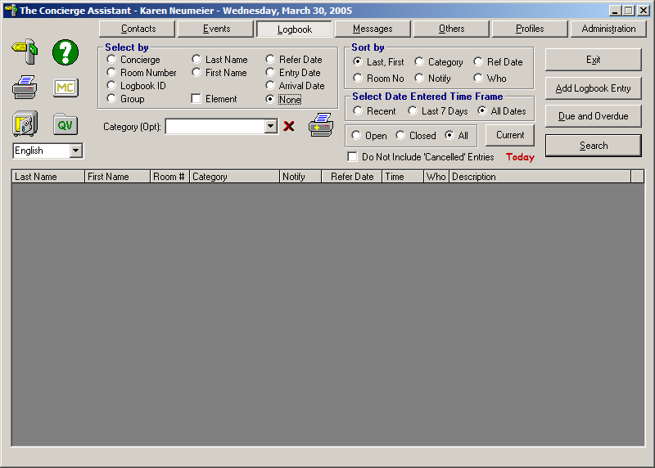

Fill out the Guest Information, select your “Package Log” category and click on the “Data Entry” form icon. This will take you to the data entry panel.”

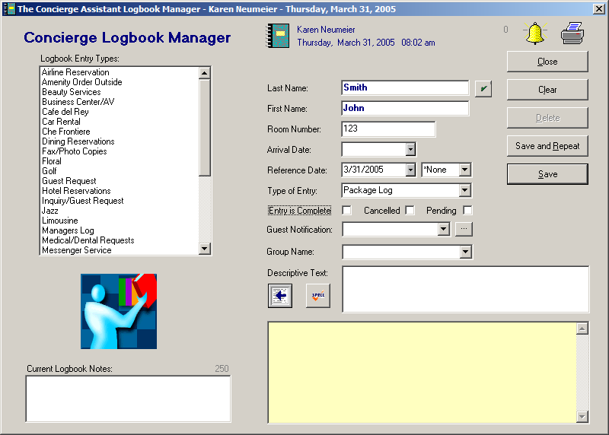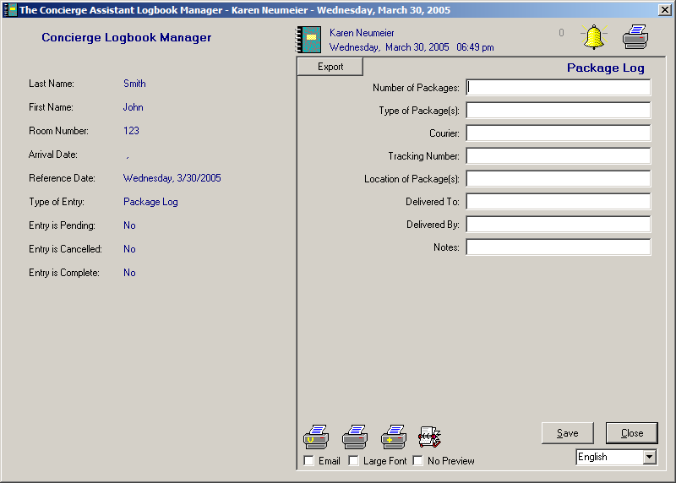

Fill out the information for the received package and click “Save”. (Note: If you happen to have the convenience of a scanner, the tracking ID can be scanned instead of keying in that information.)

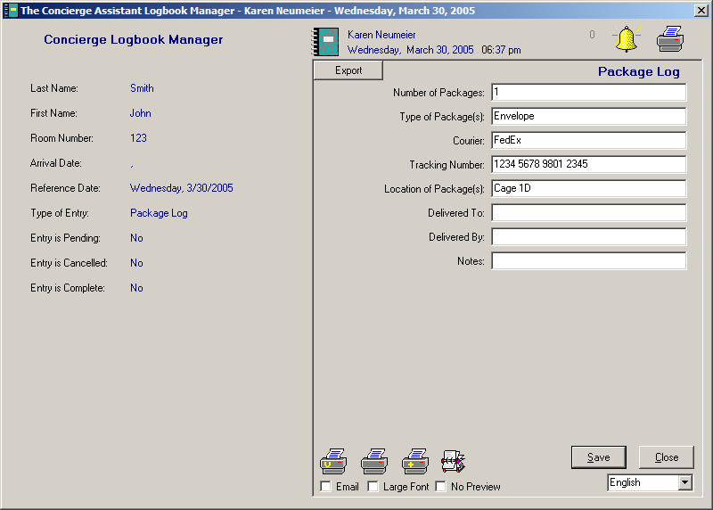

The Loss Prevention Officer on duty will assign “Delivered By” and “Delivered To” when the package is picked up.

The status of the logbook entry should be left as “Incomplete”(do not check any of these boxes).
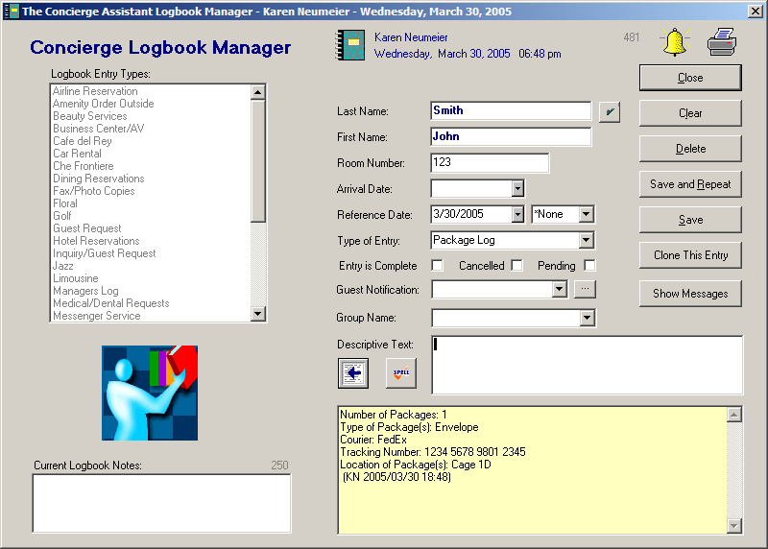

When the package is picked up, go to the “Logbook” tab and “Select By” = Last Name, select the category “Package Log”, type the name of the guest on the required field and click “Search”

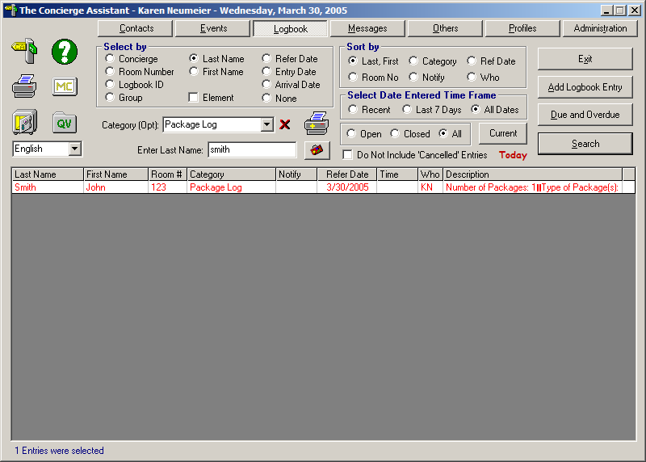

Double click on the name and the entry will open.
Put a check mark in the “Entry is Completed” box and double click on the “Data Entry” form icon.

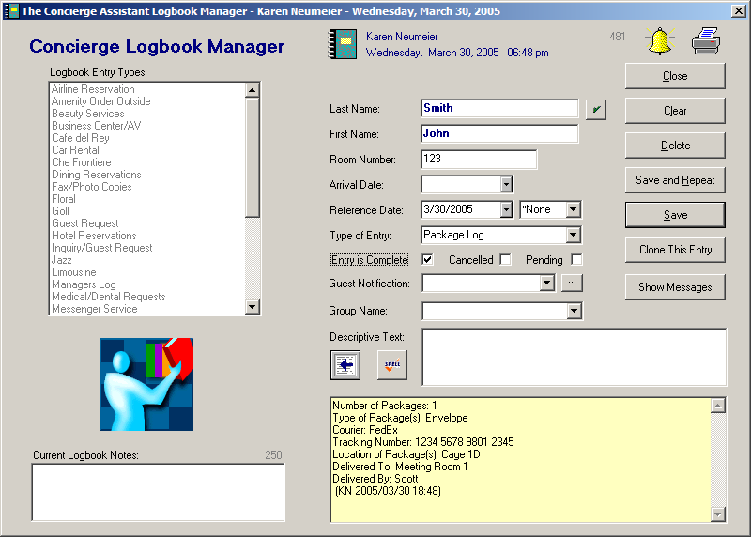

Fill out the fields “Delivered By” and “Delivered To”.

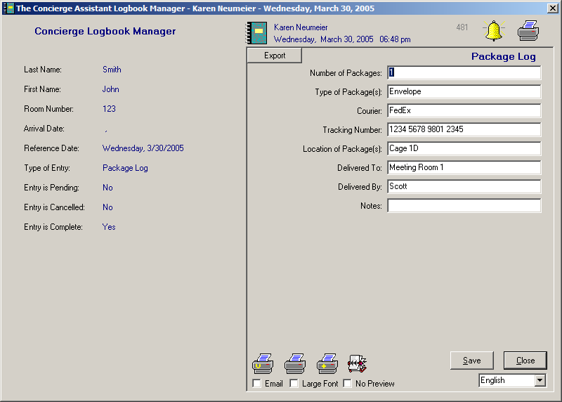

If you wish the guest to sign for the package as proof of delivery, click on the center printer icon. If no signature is required, click on the “Save” button.

If the center printer icon is clicked the following document will be printed, with a line for the guest’s signature.

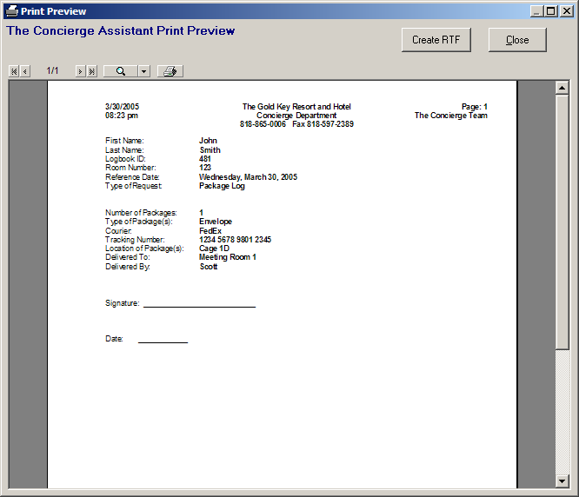

Click “Save” and Close”. The entry is complete.

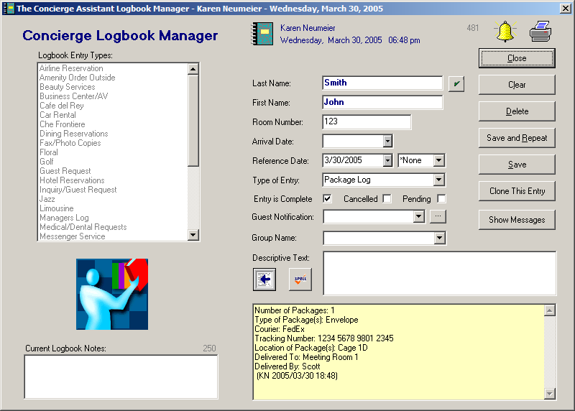

Package Process (Receiving Department Manual)

In The Concierge Assistant select the ‘Logbook’ tab and click “Add Logbook Entry”

Fill out the Guest Information, select your “Package Log” category and click on the “Data Entry” form icon. This will take you to the data entry panel.”

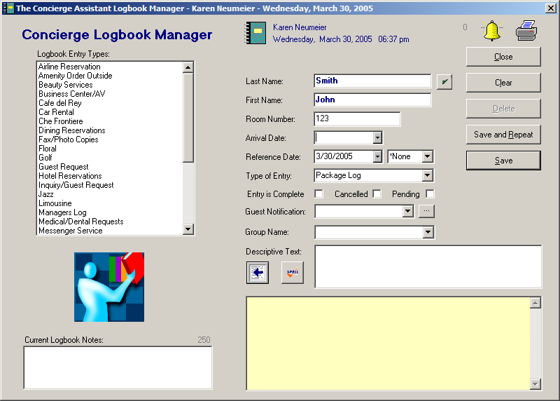

Fill out the information about the received Package and click “Save”. (Note: If you happen to have the convenience of a scanner, the tracking ID can be scanned instead of keying in that information.)

The Concierge will assign the “Delivered By” and “Delivered To” information when the package is picked up. The status of the entry should remain “Incomplete” (do not check any of the boxes).
Click “Save” and double click on the bell (Message system).

Double clicking on the bell will present you with the following screen.

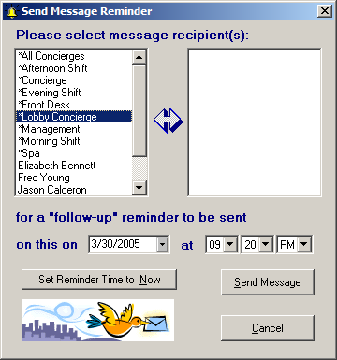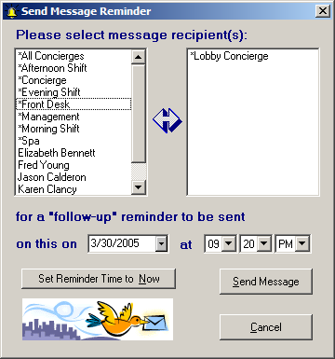

Double click on the name of the group and/or person responsible for this follow-up and the name will move into the window on the right. Click “Set Reminder Time to Now” and then click on “Send Message”.

Click Close and the Logbook entry has been established with a reminder message sent to the appropriate department for follow through.

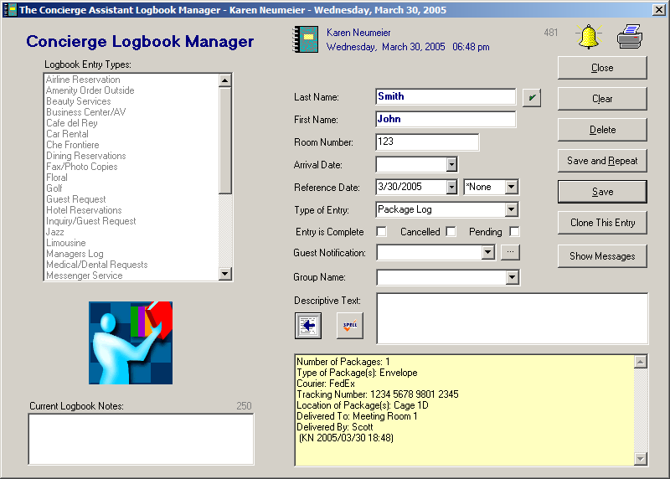

Package Process (Delivering Areas)

When a logbook message is received notifying you that a new package has arrived, double click on the logbook icon. The Concierge Assistant will bring up the associated Logbook entry.

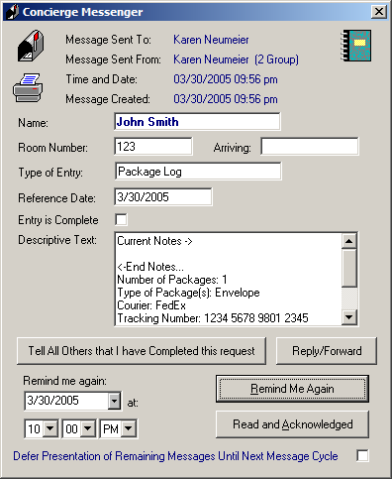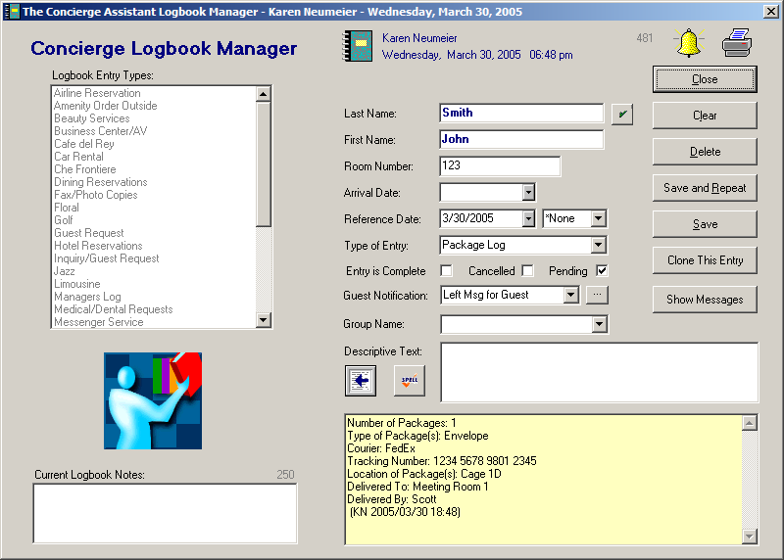

Leave a message for the guest and select the appropriate “Guest Notification”. Enter a checkmark in the “Pending” box. Click “Save” and then “Close”. Closing the logbook screen will return you to the logbook message. Click on “Tell Others that I have Completed this request”.

When the guest calls down to request their package, go to the “Logbook” tab make the “Select By” = Last Name, select the category “Package Log”, type the name of the guest on the required field and click “Search”. Double click on the name and the entry will open.

Enter a checkmark in the “Entry is Complete” box, click on the “Data Entry” form icon.

Fill in the “Delivered By” and the “Delivered To” fields. Double Click on the center printer.

Print the receipt form and hand it to the Bellman for the guest to sign. Select the Close button.

The logbook entry is now complete. Click “Save”.

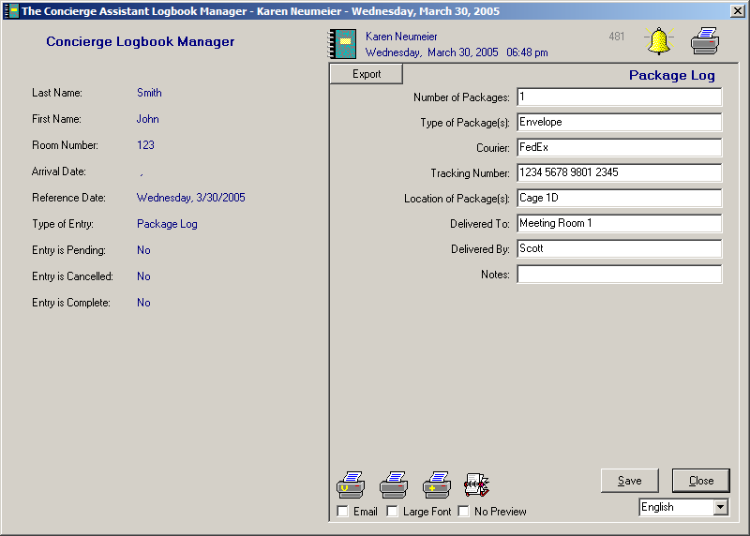

This will return you to the first portion of the Logbook entry. Click “Save” and then “Close”.

